g]kfn ;/sf/
kmf]g g+= %@)!^&
pBf]u dGqfno
3/]n' tyf ;fgf pBf]u ljefu

wg'iff

kq ;+Vof M– )&#÷)&$
rnfgL g+= M– !&@@
@)&#÷!)÷!!

ldlt M
उपयुक्त प्रविधि हस्तान्तरण सम्बन्धी सूचना ।

ljifo M–

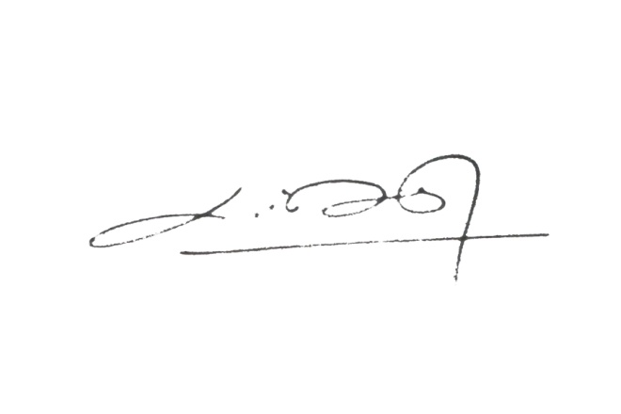
o; sfof{nsf] rfn' cf=j= @)&#÷)&$ sf] jflif{s sfo{qmd cg';f/ ælhNnf :t/df 3/]n' tyf ;fgf pBdL x?nfO{ pko'Qm k|ljlw -cf}wf]lus pTkfbg ;Fu ;DalGwt pks/0f tyf d]lzg cf}hf/_ x:tfGt/0f sfo{qmd cGtu{t 3/]n' tyf ;fgf pBf]u ljefu÷;ldlt÷sfof{no÷k|lzIf0f s]Gb| / n3' pBd ljsf; sfo{qmd P+j cGo :jLs[tL k|fKt lgsfox? af6 tflnd lnO{ o; lhNnfdf :yflkt n3' 3/]n' tyf ;fgf pBdLx?nfO{, æn3', 3/]n' tyf ;fgf pBdL k|ljlw -d]lzg, pks/0f_ x:tfGt/0f sfof{ljlw, @)^#Æ cg';f/ d]lzg cf}hf/ -d]lzg cf}hf/sf] s"n nfutsf] @)Ü /sd pBdL :jodn] j]xf]g'{ kg]{ u/L_ x:tfGt/0f ug]{ sfo{qmd /x]sf]n] OR5's n3', 3/]n' tyf ;fgf pBdLx?n] cf–cfˆgf] pBf]u Joj;fodf cfjZos kg]{ k|ljlw -d]lzg cf}hf/_ lng rfx]df of] ;"rgf k|sflzt ePsf] ldltn] #) lbg leq clgjfo{ ?kdf k]z ug'{kg]{ tkl;ndf pNnn]lvt sfuhft ;lxt tf]lsPsf] 9fFrf cg';f/ sf] lgj]bg kmf/d e/L ?= !)).– o; osf{nodf a'emfPsf] gubL /l;b ;+nUg /fvL l/t k"j{s lgj]bg lbg' x'g cg'/f]w 5 . ;fy} Dofb gf3L cfPsf] / l/t gk'u]sf] lgj]bg nfO{ pk/f]Qm sfo{qmd df ;dfj]z gul/g] Joxf]/f ;d]t o;} ;"rgf åf/f ;DaGwLt ;a}nfO{ hfgsf/L u/fOG5 . ;fy} o; ;DaGwL yk hfgsf/L rflxPdf o; sfof{nosf] kmf]g g+= )$!–%@)!^& df sfof{no ;do leq ;Dks{ /fVg' xf]nf / k|:t't ;"rgf / lgj]bg sf] 9fFrf 3/]n' tyf ;fgf pBf]u ljefu sf] j]a ;fO6 www.dcsi.gov.np df klg x]g{ ;lsg]5 .
tkl;n
;+nUg ug'{kg]{ cfjZos sfuhftx? M
!= pBdLsf] gful/stf sf] k|ltlnlk
===========================
-pBf]u clws[t_

@= pBf]u btf{÷gljs/0f k|df0f kqsf] k|ltlnlk
#= Kofg÷Eof6 btf{ k|df0f kqsf] k|ltlnlk
$= s/r'Qmf k|df0f kq -ut cf=j= ;Dd sf]_
%= pBf]u sf] Joj;flos of]hgf -l:sd_
^= cg'ej tyf tflndsf] k|df0f kqsf] k|ltlnlk

